Style Guide

IASPM Editorial Team
IASPM Journal
institutional@email.com

Abstract
Please refer to the template for detail on the formatting of the abstract and main text sections. Though, this guide also adheres to the same template formatting.
Keywords: IASPM Journal, Harvard referencing,

Harvard System of Referencing in IASPM Journal
In case you do not find the formatting for an item in this Style Sheet, please check the following sources:

The Open University. Quick guide to Harvard referencing (Cite Them Right) https://university.open.ac.uk/library/referencing-and-plagiarism/quick-guide-to-harvard-referencing-cite-them-right. Accessed: 26 August 2026.
Citethisforme.com Harvard Referencing Generator. http://www.citethisforme.com/. Accessed: 14 February 2018.

Abbreviations
Latin abbreviations are used for the following:
c. (circa)
cf. (compare)
et al. (and others)
ibid. (in the same work)

In all other cases, the full word should be employed rather than an abbreviation:
versus, and, number, for example. Do not use shortened forms (etc., e.g., no., i.e.).

Numerals
Numbers under 100 should be expressed as words in the main text:
There were eighty-four people at the concert.

Numbers over 100 should be expressed as figures in the main text:
647 people attended the concert.

In cases with particularly large numbers, a combination of words and figures is acceptable to make reading less cumbersome:
The group sold more than 1 million albums.

Spans of numbers should be linked with a figure dash (similar to minus hyphen):
135-139 George Street

Precise expressions of time and currency should be expressed in numbers:
The concert began at 10.30 p.m. and lasted three hours.
Since the release of the Live Aid DVD and Band Aid single in November 2004, the Band Aid Trust has received income in excess of 6.5 million.

Dates
Dates both in the main text and in the references list should be expressed in the full form: 10 September 1987. The use of words or figures to express spans of years is acceptable in the following: The seventies / 1970 (do not use ‘70s or nineteen-seventies).

Tables, graphs, diagrams and music examples
All images (graphics, figures and musical examples) should be sent in jpg format and have a caption text. They will be inserted by the lay-out editor in the corresponding place in the text, numbered and identified with the caption. The requirements for a photograph, diagram or illustration are a minimum of 300dpi (dots per inch) for photographs, 1200dpi for line art. For musical examples in notation are a minimum of 300dpi. Video fragments must be sent in MPG or AVI format, audio fragments in MP3 or WAV. Submit images grouped together into a compressed folder, submitting this separately from the paper.

Captions
CAPTIONS: Optima 11, centred.

All images (graphics, figures and musical examples) should be numbered successively and referred to in the text. Captions should also contain a note on permission for reproduction, in brackets.
A distinction should be made between TABLES and FIGURES:
- A table is a chart created on a word processor; a table can be provided as a Word document, and one can usually print a table with a standard printer.
- A figure is a photograph, diagram or illustration. A figure also refers to a musical transcription (of various forms, not necessarily 5-line staff notation). Full figure references should be presented as Endnotes.

A - Captions for tables should appear before the table (see Table 1).

TABLE 1. Text of caption: Optima 11, centred.

TITLE
Text
Text

B - Captions for figures, including graphs, photographs and musical examples, should appear after the figure (see Example 1 and Figure 1):
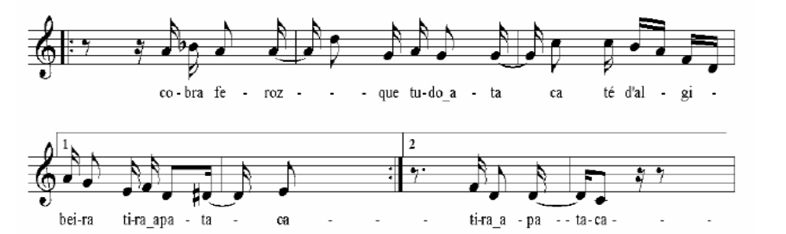

FIGURE 1. Lá no largo da Sé velha, part 2, composed by Candido Inácio da Silva (1800 - 1838). Optima 11, centred.

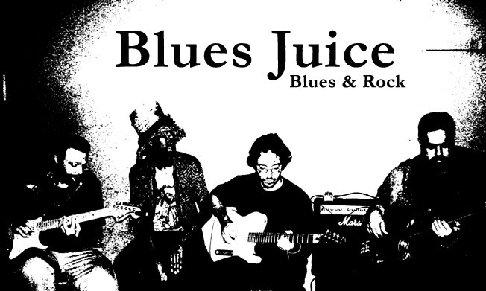

FIGURE 2. The Blues Juice. Optima 11, centred.

Add an Endnote to indicate the source of the image where necessary (for example, if the image is not the author’s):
Blues Juice Blogspot http://bluesjuice.blogspot.com/2010/07/agenda-blues-juice-de-0807-1007.html. Accessed: 28 June 2009.

References
Example, O. 2026. Formatting for Reference List. New Copy for updated references.
Format references in Optima 12, Align Left, with hanging line of 0.5 indent, in Harvard Style of Referencing.

All titles are presented as: Capital Letters at the Start of Nouns.
All books, book chapters, journal articles, dissertations, newspaper articles, magazine articles, television, film, radio, web and music sources should be listed in the References section, at the end of the text, after the Acknowledgements. These may then be organised further into the following subsections, with subtitles in list of reference in Optima 14, Italic, Align Left:

Bibliography
Listing works by the same author, published in the same year
In your reference list, order these works alphabetically according to the title of the work and use the letters a, b, c ... after the publication date to distinguish between them in your citations:

Frith, S. – (use en-dash --)
1996a. Entertainment. In J. Curran and M. Gurevitch Eds. Mass Media and Society. London and New York: Arnold.
1996b. Performing Rites: On the Value of Popular Music. Cambridge, Mass: Harvard University Press.

Books
Books should cite the author surname and first name, year of publication, title in italics, name of publisher, location of publisher, and numbered edition if not a first edition:

Marcus, G. 1991. Mystery Train: Images of America in Rock ‘n’ Roll Music. London: Penguin.

Chapters from Edited Books
Chapters from Edited Books should include the author(s) surname and first name, year of publication, title of chapter. In, Author(s)/Editor(s) of book (if different), title of book in italics, publisher, place of publication, page numbers:

Idel, M. 1997. Conceptualizations of Music in Jewish Mysticism. In L. E. Sullivan Ed. Enchanting Powers: Music in the World’s Religions. Cambridge: Harvard University Press: 159-188.

Journal Articles
Journal articles should include the author(s) surname and first name, year of publication, title of article, journal name in italics, volume number, issue number, page number(s):

Bradby, B. 1993. Sampling Sexuality: Gender, Technology and the Body in Dance Music. Popular Music 12 (2): 155-176.

Where available, add the DOI number, prefixed by http://dx.doi.org/ (no need for date of last access, because the doi is registered to remain with the publication):

Bradby, B. 1993. Sampling Sexuality: Gender, Technology and the Body in Dance Music. Popular Music 12 (2): 155-176. http://dx.doi.org/10.1017/S0261143000005535

If a DOI number is absent from an online journal, please provide the website address instead. This time, however, add the last date of access.

Web Sources
Web sources should include the site author (person or organisation), year of publication, Title of page(s) viewed, and web location of the article and date of access:
RIAA – Recording Industry Association of America .2014. RIAA – RIAA. http://www.riaa.com/aboutus.php?content_selector=about-who-we-are-riaa Accessed: 20 May 2014.

Collective article or book up to two authors
Brøvig-Hanssen, R. and Harkins, P. 2012. Contextual Incongruity and Musical Congruity: the Aesthetics and Humour of Mash-ups. Popular Music 31 (1): 87-104. http://dx.doi.org/10.1017/S026114301100047X

Collective publication of more than two authors
Verhagen, S. et al. 2000. Fast on 200 Beats per Minute: The Youth Culture of Gabbers in the Netherlands. Youth & Society 32 (2): 147-164. http://dx.doi.org/10.1177/0044118X00032002001

Author as editor
Nettl, B., Ed. 1998. In The Course of Performance: Studies in the World of Musical Improvisation. Chicago: University of Chicago Press.

Dissertations / Theses
Masters and doctoral theses should cite the author surname and first name, year of publication, title of thesis in italics, the award/degree granted, university of study and the location of the university:
Doyle, P. 2001. Race with the Devil: Space, Place and Motion in Popular Music Recording, 1900–1960. PhD. Macquarie University, Sydney.
Internet locations of theses should also be provided if available (such as for university library online thesis registries), with date of access.

Conference Papers
The required elements for a conference paper are: author, year. Full title of conference paper. In: followed by editor or name of organisation, Full title of conference. Location, Date. Where relevant, add: Place of publication: Publisher. Web location, date of last access.
D’Amato, F. 2003. Dance Tribes and Club Cultures. Experiences, Imageries and Values Concerning Dance Clubs in Rome. International Association for the Study of Popular Music, IASPM 12th Biennial Conference, McGill University: Practicing Popular Music. Montreal, 3–7 July 2003. www.iaspm.net/archive/IASPM03sm.pdf. Accessed 14 April 2012.

Newspaper and Magazine Articles
Newspaper and magazine articles should cite the author(s) surname and initial, year of publication, title of article, newspaper or magazine name italicised, day, month, page number(s). The full Internet location of the article should be provided if available and date of last access.

- Known author of a newspaper/magazine article:
Donovan, P. 2007 The day the music in nightclubs got dearer. The Age, 11 July. http://www.theage.com.au/news/entertainment/latest-dance-hit-doofdoofdoof-kerching/2007/07/10/1183833519305.html. Accessed: 28 June 2009.

- Unknown author of a newspaper/magazine article:
Rolling Stone. 2009. Bruce Springsteen on his Super Bowl Slide: Rocker Opens Up. in Candid Journal, 11 February. http://www.rollingstone.com/rockdaily/index.php/2009/02/11/bruce-springsteen-on-his-super-bowl-slide-rocker-opens-up-in-candid-journal/. Accessed: 28 June 2009.

To include a newspaper or magazine article where the author is unknown in the main text, cite the publication title and year of publication:

Rolling Stone (2009) reported on the thoughts of Bruce Springsteen after his U.S. Superbowl half-time performance.

Encyclopaedia Entry
Encyclopaedia entries should cite the author(s) of the entry – surname and initial – Year of publication, Title of article in double quotation marks, Full title of Encyclopedia Work in italics, Volume Number and Title, page number(s):

Laing, D. 2003. Copyright. In Continuum Encyclopedia of Popular Music of the World, Volume 1, Media, Industry and Society: 480-485.

Discography
Music recordings
State the name of the artist, year of release, title of the album or single recording, title of the album in italics, name of the recording label, and date and country of issue. Individual song titles should be in double quotation marks:

Franz Ferdinand. 2005. “Do You Want To”, You Could Have It So Much Better, Sony BMG, 2 October, Australia.

If the exact date of release is not available for all discographic sources, please use only the year.
To include discography sources in the main text, cite the author/organisation and year of publication:

Franz Ferdinand’s single “Do You Want To” (Sony BMG 2005) from their You Could Have It So Much Better album has featured in television commercials.

Radio programs
State the name of the radio network, year of first airing, program title, program date, and Web location if available as a stored audio file:

BBC. 2009. Sounds of the 60s, Radio 2, 14 February, http://www.bbc.co.uk/radio2/shows/sounds60s/. Accessed: 28 June 2009.

In the main text, a radio source is indicated through broadcast company and year of broadcast:

Brian Mathews’ Sounds of the 60s program (BBC 2009) airs a range of 1960s pop and rock hits and artist interviews.

Videography
Audiovisual references should appear in a separate list. Please use the format listed below as a guideline; authors can add information deemed necessary for an accurate identification of the source.

Films
State the Film Title in italics, year of release, name of director, name(s) of publishing and/or distribution companies:

Billy Elliot. 2000. Dir. Stephen Daldry, Working Title/Universal Studios.

In the main text, a film is referenced through indicating director and year of release:

The film Billy Elliot (Daldry 2000) has been reconstructed as a stage musical in many countries.

DVDs
The Rutles: All You Need Is Cash. 2001. Dir. Eric Idle and Gary Weis. DVD. Rhino Video.

Television programs
Cite the name of the television network, year of first viewing, program title, episode title, (season number, if relevant, as well as episode number in brackets), program date, name(s) of publishing and distribution companies:

BBC. 2001. Jazz: A Film by Ken Burns, “Gumbo” (episode one), 9 June, PBS.

In the main text, a television programme is indicated through broadcast company and year of broadcast – unless it is a film that has its own release date and identifiable director.

Online video
Format: Author’s surname, Initials or username (year created/uploaded) Title of video [Online video]. Available from: URL Accessed day month year.

Stanford Humanities (2011) The art of living - R Lanier Anderson [Online video]. Available from: http://youtu.be/-YnLyBRvAw. Accessed 18 May 2014.

In text citation: (Stanford Humanities, 2011)

Interviews
Name of interviewee, year of interview, name of interviewer, place and remainder of the date:

Kenny Carpenter. 2012. Interviewed by Kai Fikentscher, Berlin, 14 April.

Social media sites (Facebook, Twitter)
Author’s surname, Initials or username (Year published) Title of message, Title of site, day and month of post. Available from: URL. Accessed day month year.

Smith, T. (2012) Referencing, Twitter, 14 June. Available from: http://twitter.com/tomsmith/informationliteracy. Accessed 15 July 2012.

In-text citation: (Smith 2012)

For any other type of sources, please always refer to Harvard style of referencing in the guides above.

Online Privacy Ethics
Please follow the guidelines in the infographic below proposed by Ellis Jones to the IASPM Journal editorial board in July 2023 and approved at the editorial board meeting in December 2023.
