FIGURES: The Concept Album as Visual – Sonic - Textual Spectacle: The Transmedial Storyworld of Coldplay’s Mylo Xyloto

Figure 1: Paris, Graffiti art for Mylo Xyloto

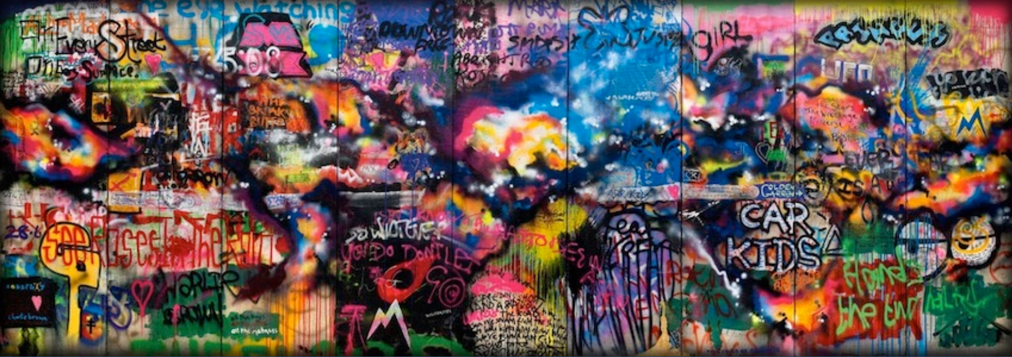

Figure 2: Mylo Xyloto album artwork

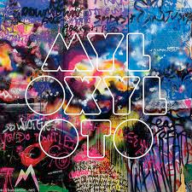

Figure 3: Screenshots from music videos: a) “Every Teardrop Is A Waterfall”; b) “Paradise”; c) “Charlie Brown”; and d) “Hurts Like Heaven”

a. [01:46] | 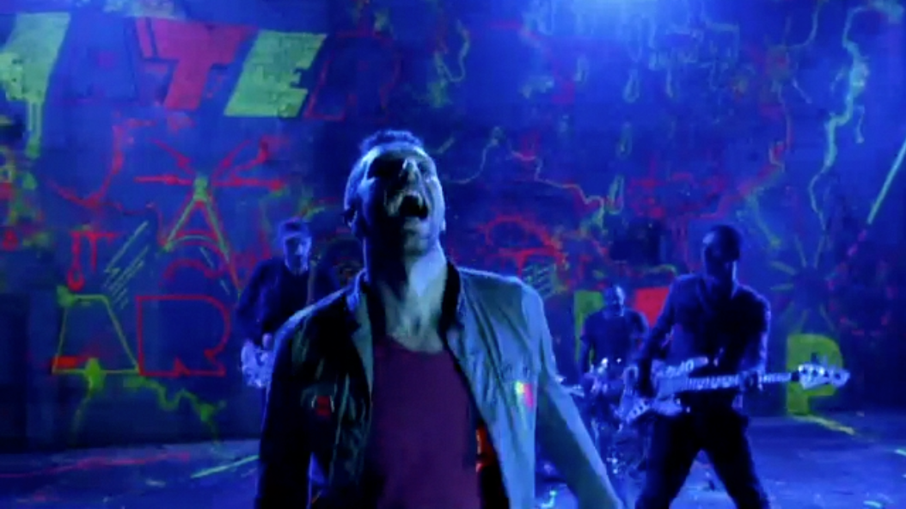
b. [01:23] | 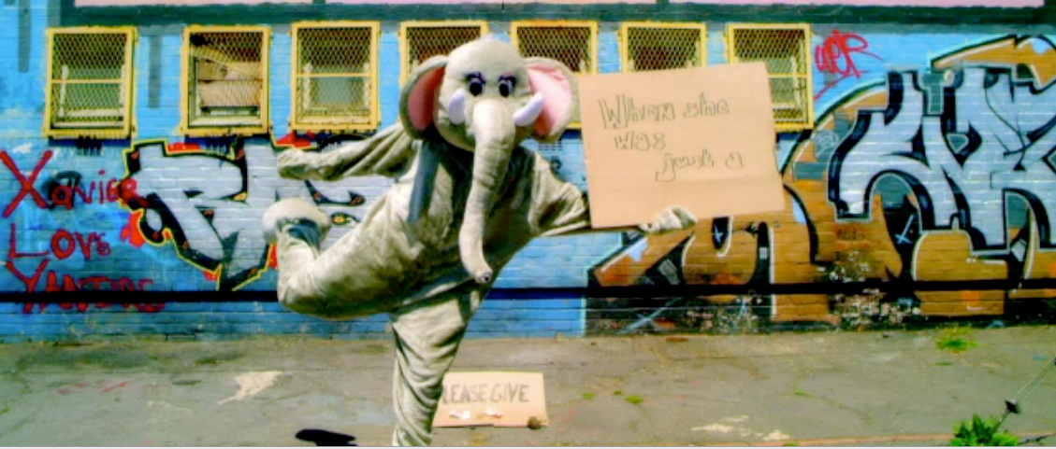
c. [01:03] | 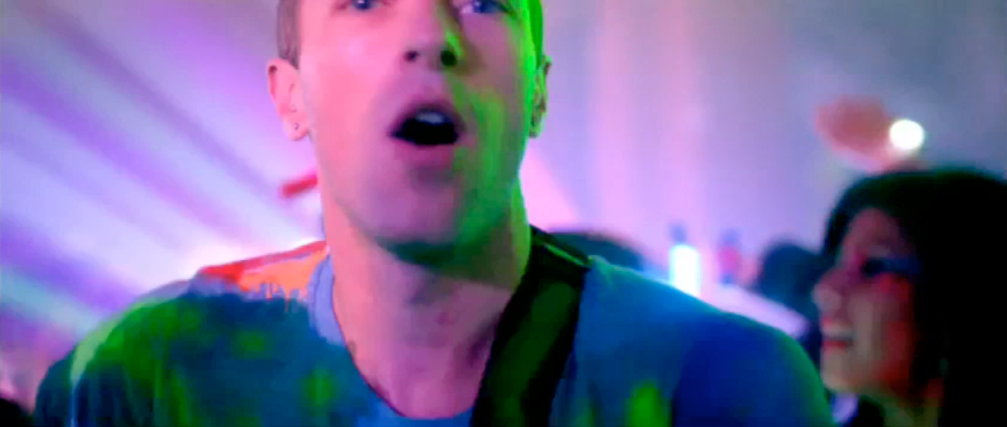
d. [00:19] | 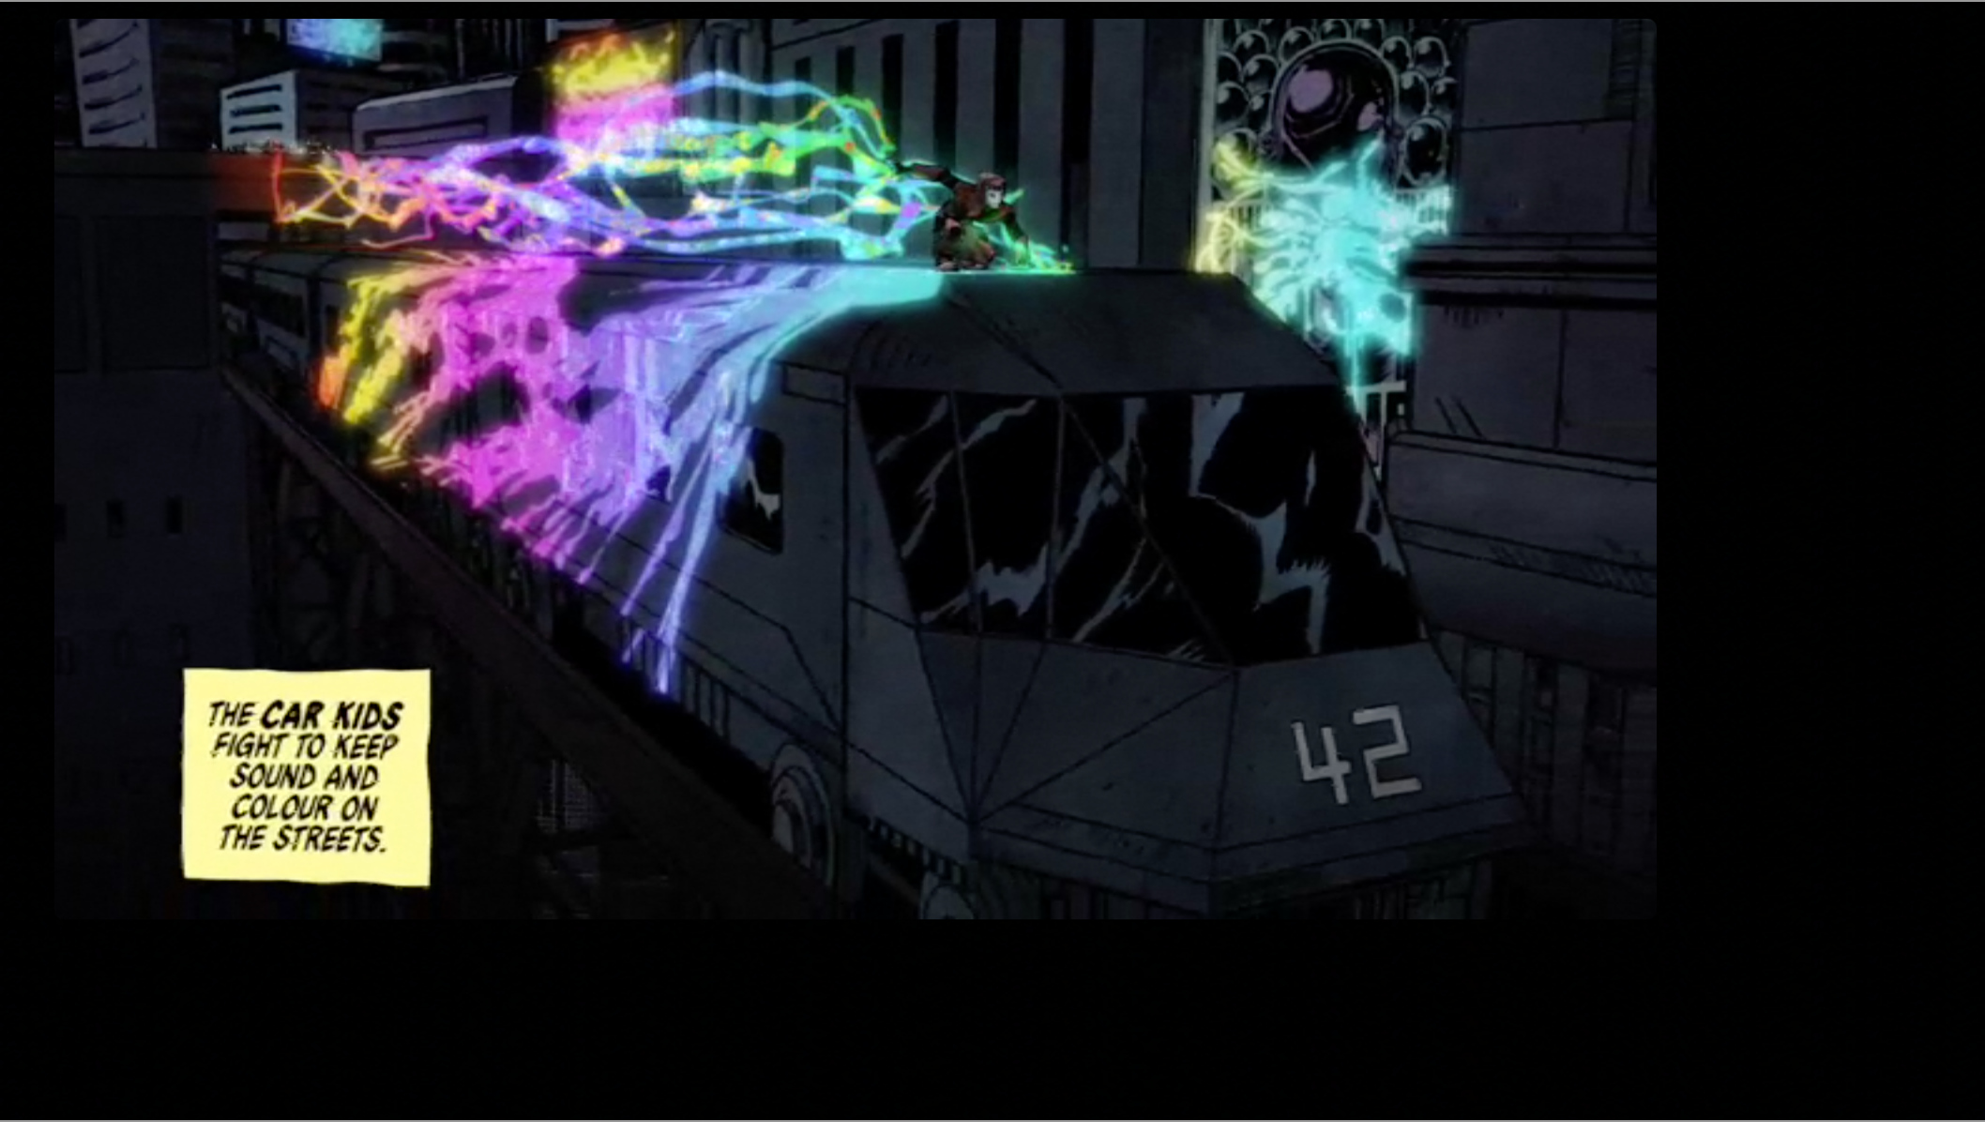

Figure 4: Mylo Xyloto Release Timeline

3 June 2011 | 1st single: Every Teardrop is a Waterfall (ETIAW)
25 June | Glastonbury Festival Concert (including 7 tracks from MX)
26 June | EP release: ETIAW, Major Minus, Moving to Mars
28 June | Video: ETIAW
12 August | Artwork and Album Title release
12 September | 2nd single: Paradise
17 October | Video: Paradise
19-25 October | Mylo Xyloto release: EMI, Parlophone, Capitol
19 October | Steve Jobs Memorial: closed set with ETIAW
26 October | Mylo Xyloto Tour 1st concert in Madrid
14 November | 3rd single: Charlie Brown
3 February 2012 | Video: Charlie Brown
13 April | 4th single: Princess of China, feat. Rihanna
21 April (record store day) | Ltd. ed. single: Up With the Birds (7” vinyl)
2 June | Video: Princess of China
27 July | 5th single: Hurts Like Heaven
9 September | Live performance at the London 2012 Paralympic Games, Closing Ceremony
8 October | Video: Hurts Like Heaven
13-14 November | Coldplay Live 2012; cinema screenings
31 December | Mylo Xyloto Tour last concert in NYC
January – July 2013 | Comics 1-6 released
20 April 2013 (record store day) | Ltd.ed.: album, comic 1, 7” vinyl Hurts Like Heaven and Us Against the World

Figure 5a: Charlie Brown, waveform and musical structure

Intro/Hook | Verse | Hook | *Verse + R | Hook + R | Bridge + R | Intro Reprise  Hook | Outro + R | Postlude

Figure 5b: Charlie Brown, summary of sonic flow
Intro [00:00]:
ambient atmosphere: sped-up vocals, gradually emerging guitar create altered sense of space and time
Hook [00:26]:
heavy rock texture: depth and layering with bass, kick drum, prominent lead guitar doubled by higher synth
-centered, vocal falsetto opens registral space
Verse [00:53]:
intimate space: compressed, dry vocal with stripped down acoustic accompaniment and centered mix
-doubled guitar split L & R to set off the centered vocal
-faint electric guitar heard in R channel
Hook [01:18]
Verse 2 and Refrain [01:32]:
-back-up vocals split L & R create sense of depth, breadth, distance
Hook and Refrain [02:04]:
-refrain with backing vocals
-increase in intensity leads into Bridge
Bridge [02:29]:
“alternative” space: doubling of voice and guitars, back-up vocals, additional synth sounds, registral expansion, distorted bass at end of section
Intro reprise/Hook [02:59]:
ambient atmosphere returns
heavy rock texture of hook returns [03:24]
Outro + Refrain [03:50]:
-higher falsetto range
-final statement of refrain shift from reverberant staging to intimate, dryer sound at end of phrase
Postlude [04:11]:
distance: muted piano creates effect of nostalgia
-synth tone clusters in high register sustain dissonance

Figure 6a: Structural features of “Charlie Brown”
key: B flat
meter: 4/4
tempo: 136 bpm
lyrical refrain (R): “We’ll be glowing in the dark”
Hook and Verse based on 8-bar phrase (a + b)
a = 4 bars: Gm7 | E♭* | B♭ | B♭ [* = 2/4 bar]
b = 4 bars: Gm7 | E♭M7 | E♭M7 | Cm7
c = 4 bars: E♭ | E♭ | Fsus4 | Fsus4
d = 4 bars: Fsus4 | Fsus4 | E♭6 | B♭
R = 4 bars: E♭ --

Figure 6b: Formal summary
00:00 | 00:53 | 01:18 | 01:32 | 02:04 | 02:29 | 02:59 | 03:50 | 04:11
Intro/Hook | V1 | Hook | V2+R | Hook+R | Bridge | [Intro] | Outro | Postlude
ab X 4 | ab X 2 | ab X 1 | abacR | ab[R]ab | dd’R | ab X 8 | aR | B♭ E♭9

Figure 7: “Charlie Brown” Music Video Screenshots

a. [00:02] | 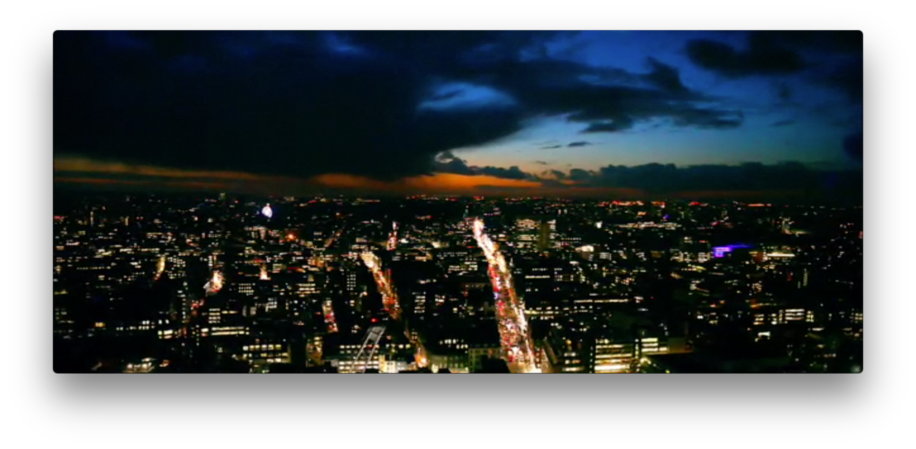
b. [00:27] | 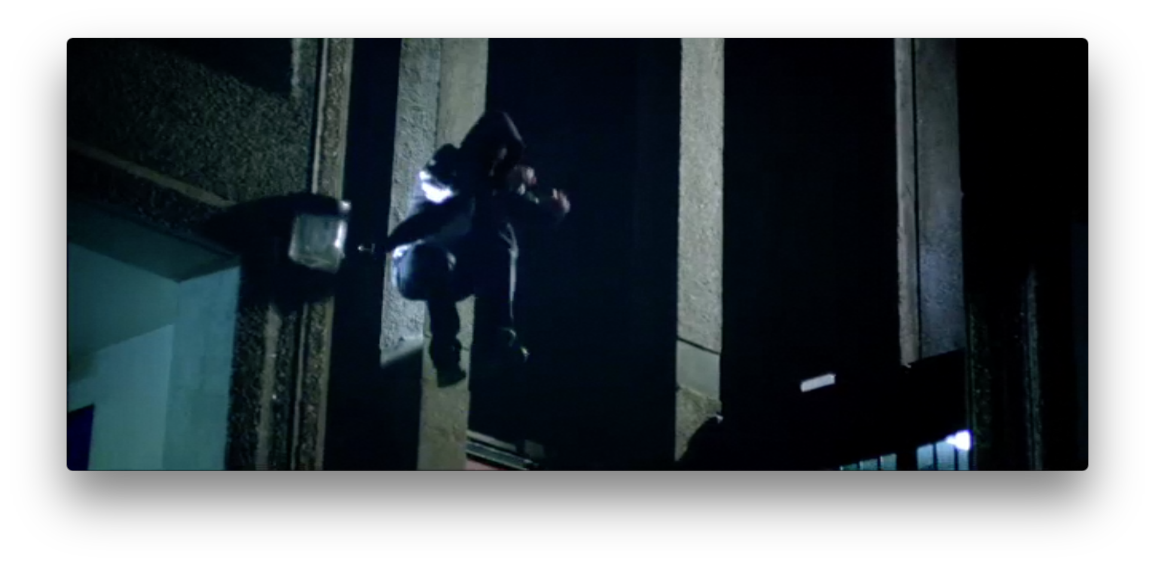
c. [00:51] | 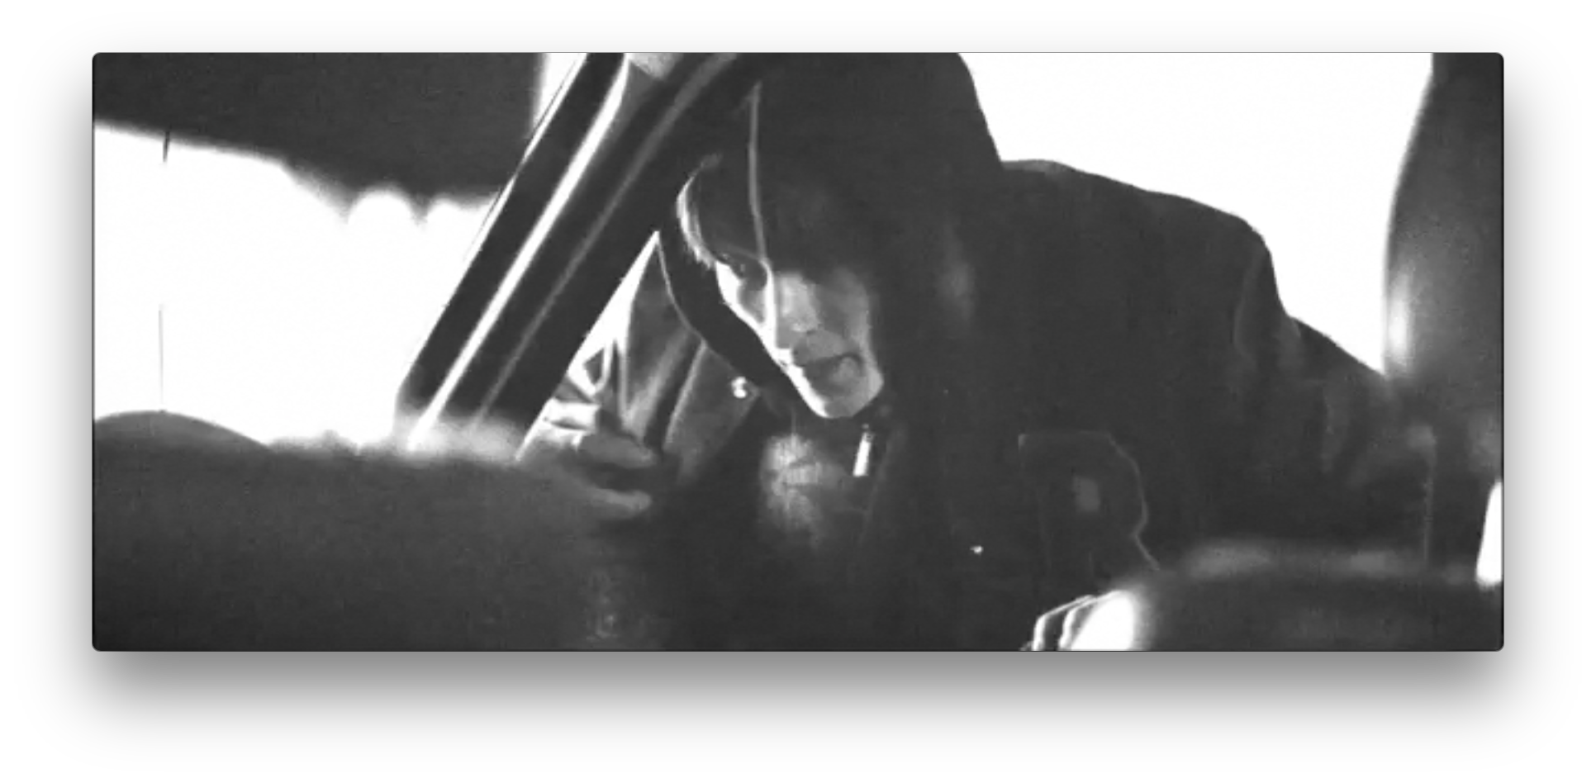
d. [02:27] | 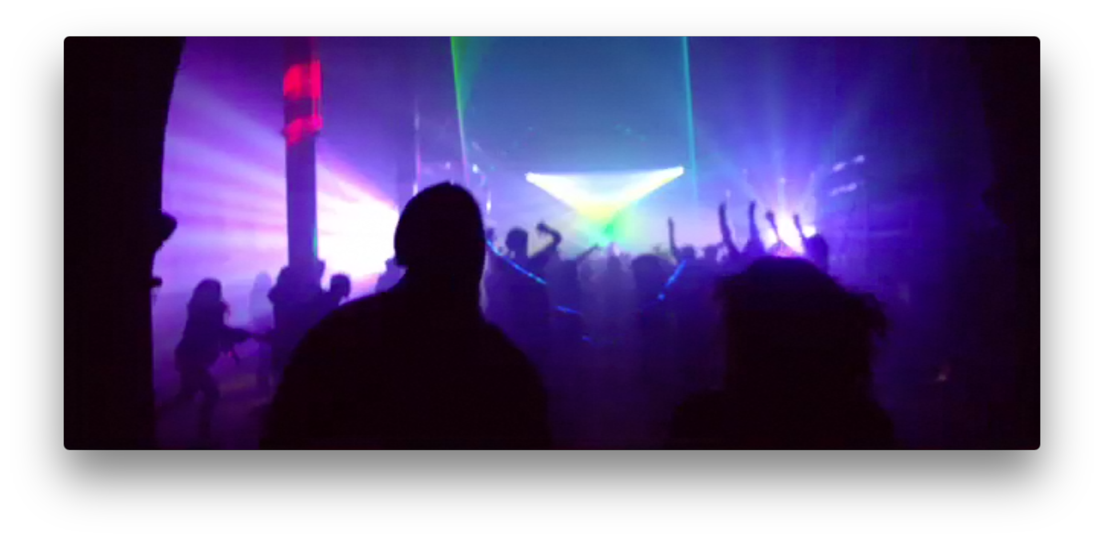
e. [02:39] | 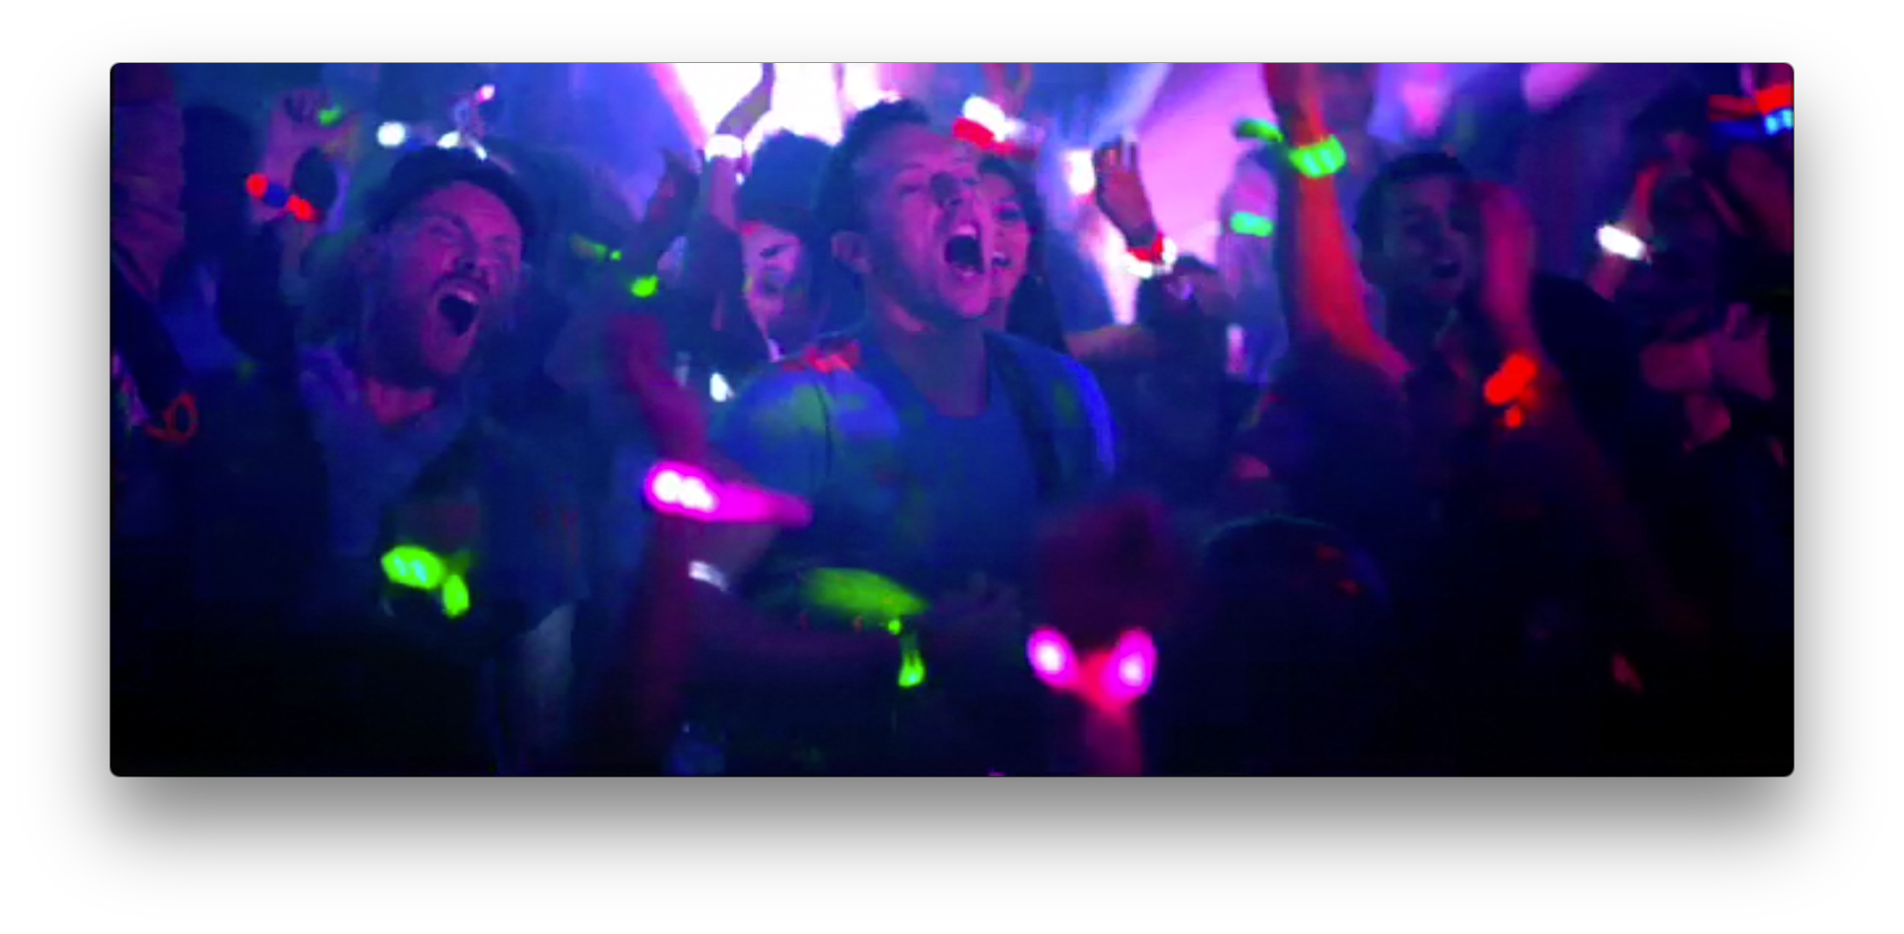
f. [02:49] | 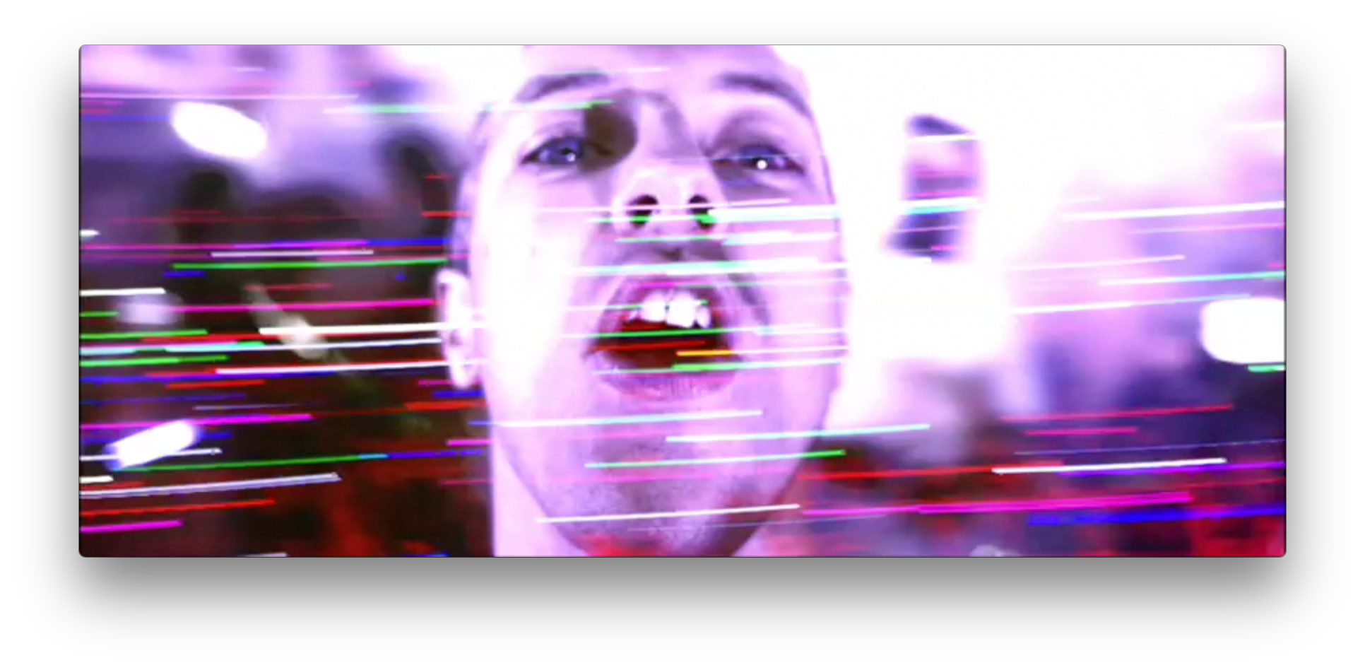

Figure 8: Screenshots from Live 2012, “Charlie Brown” performance

a. [55:43] | 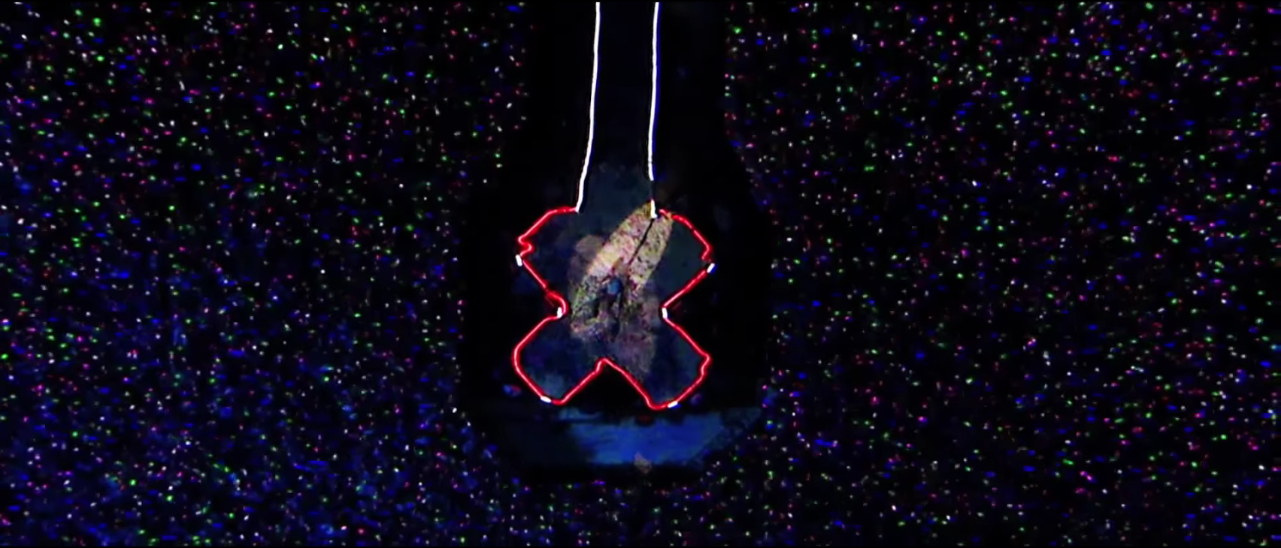
b. [56:10] | 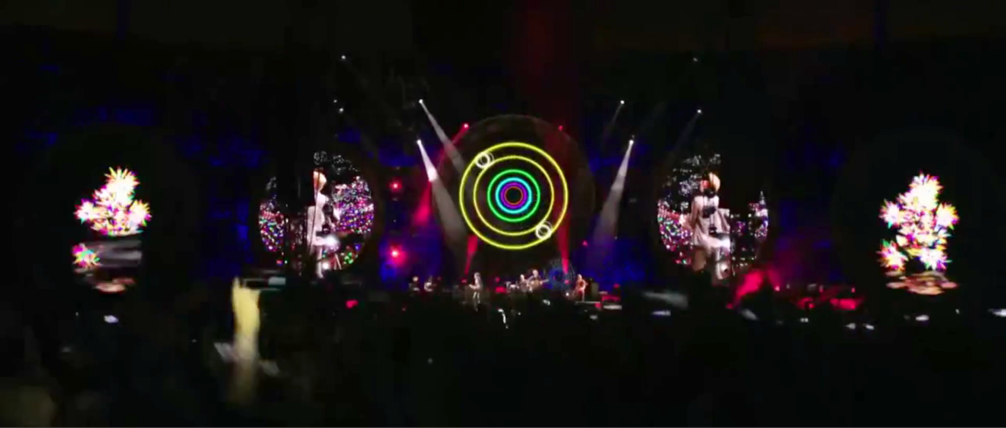
c. [57:02] | 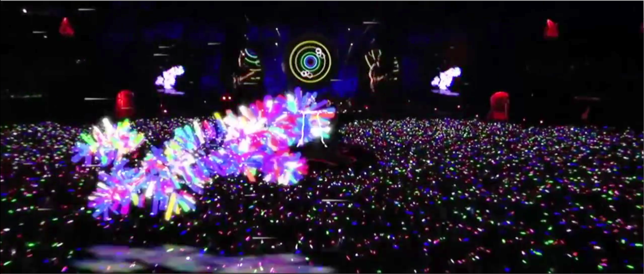
d. [57:56] | 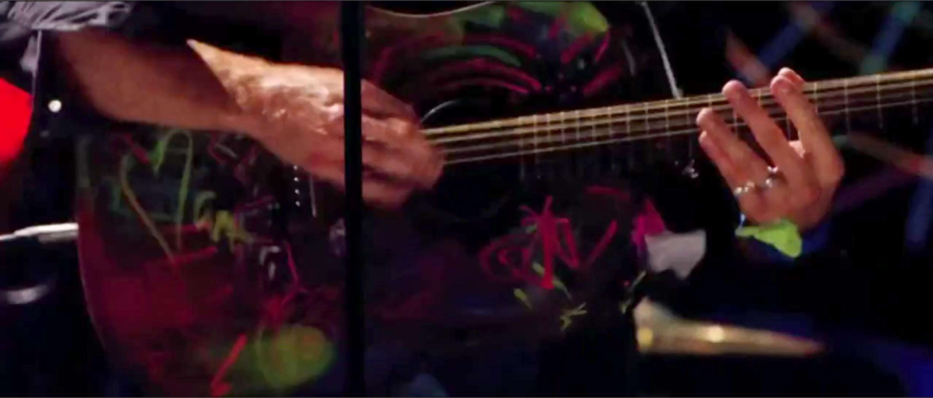
e. [57:56] | 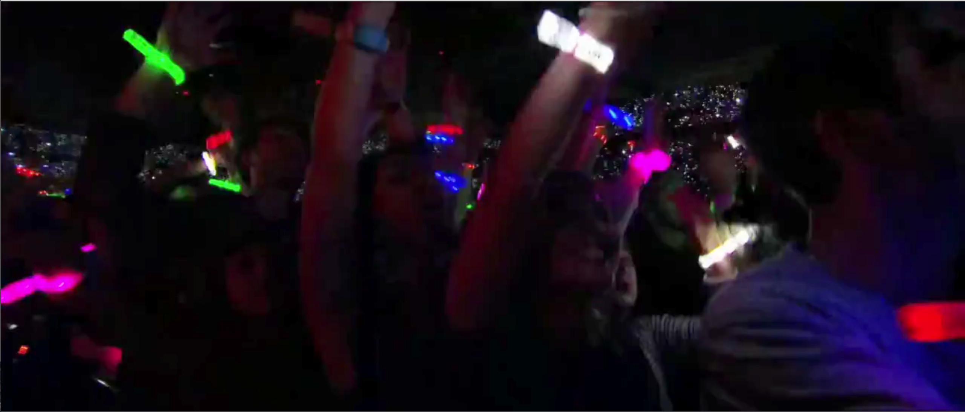

Figure 9: Screenshots from “Hurts Like Heaven,” preview video for the comic book series

a. [00:57] | 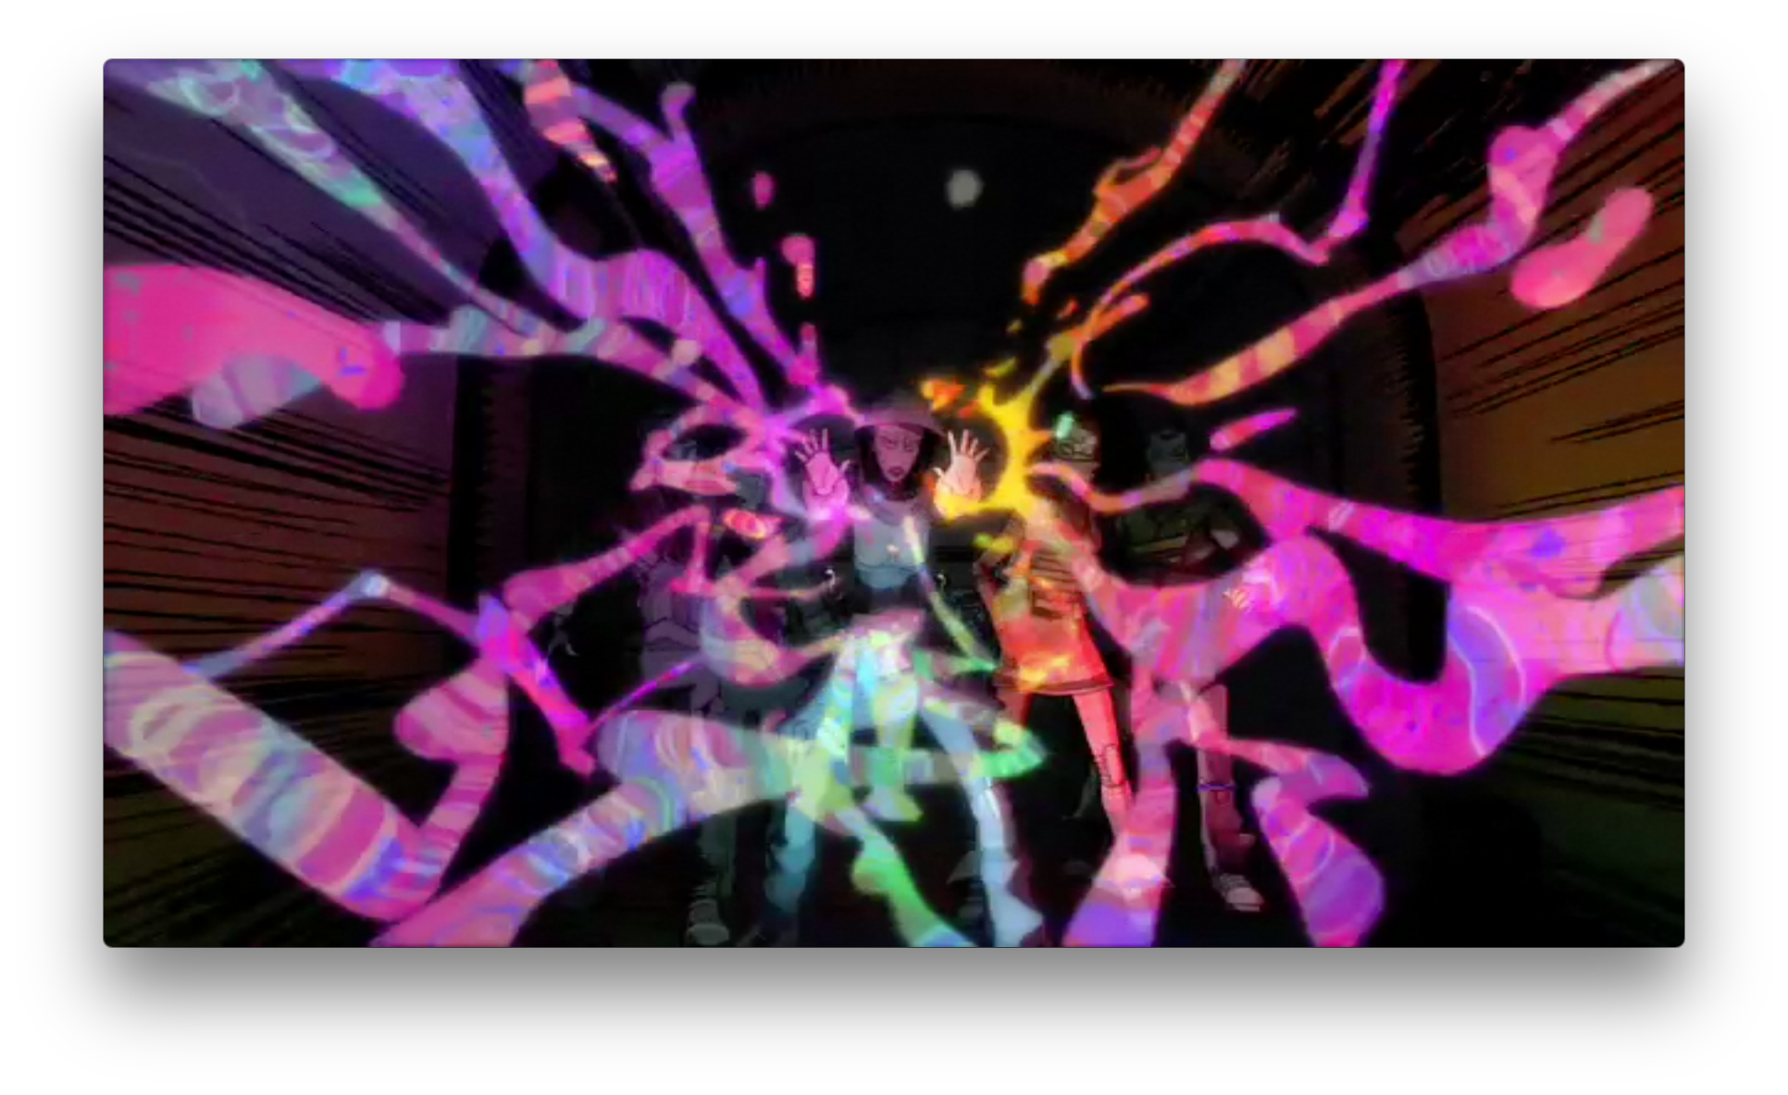
b. [01:49] | 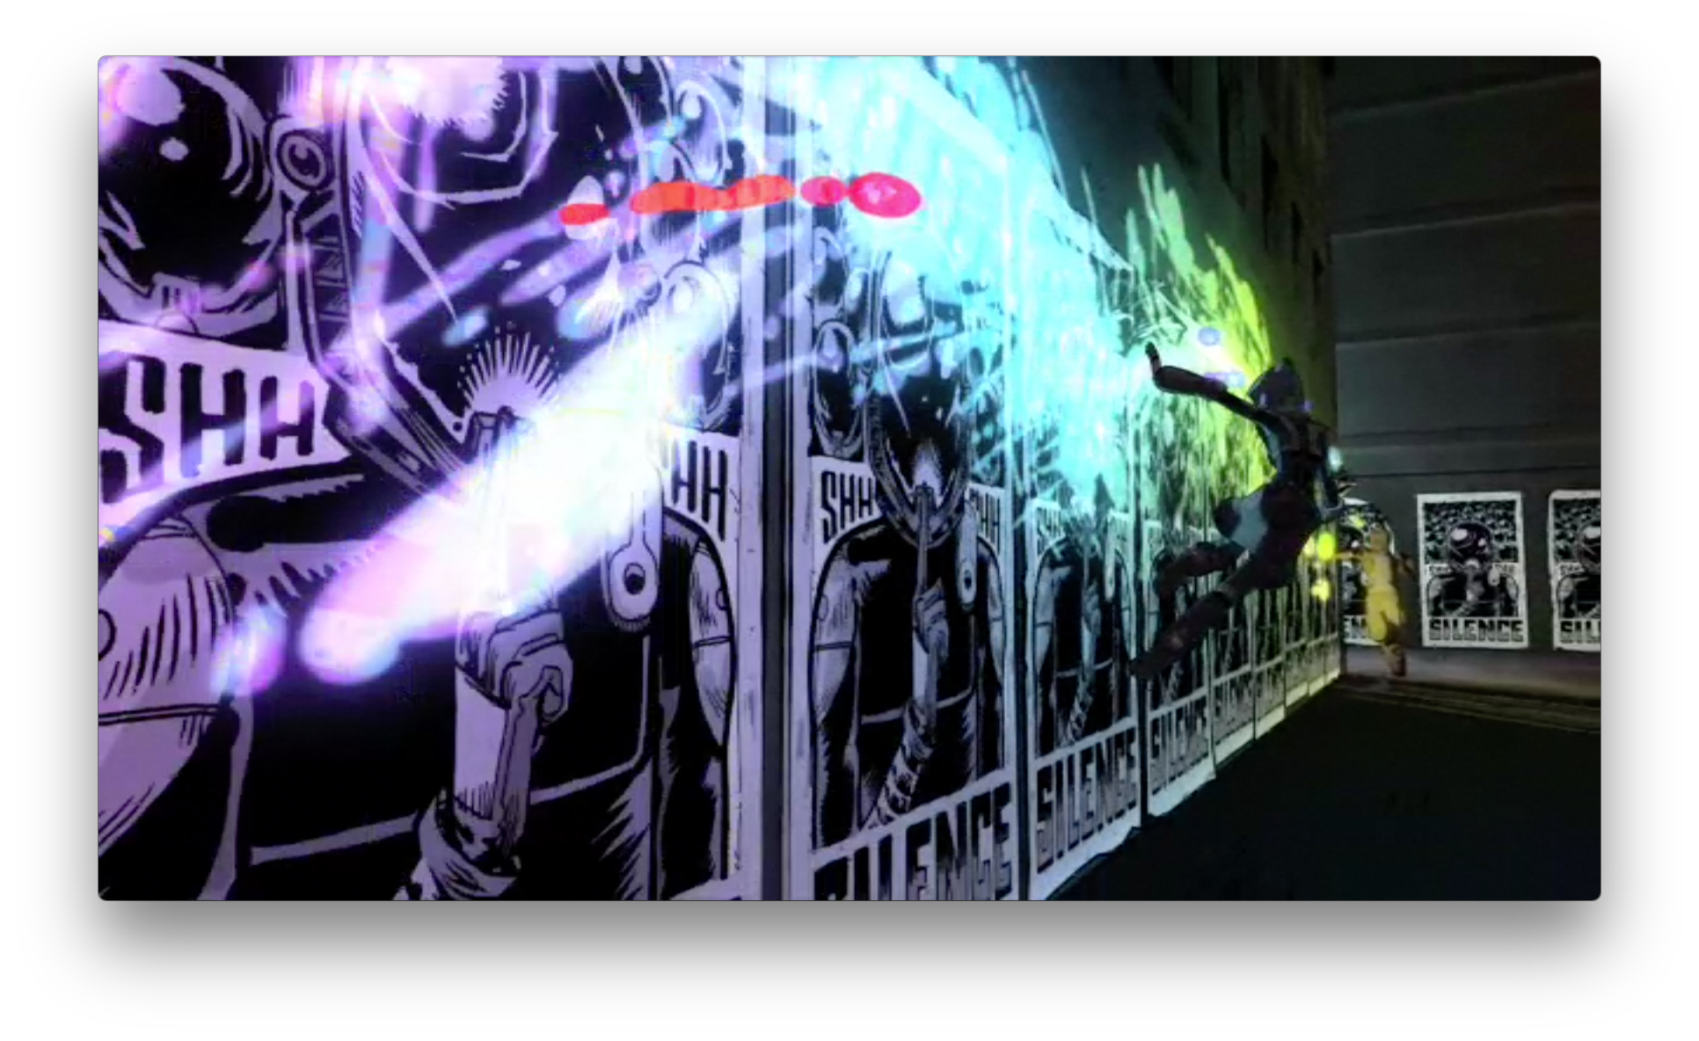
c. [02:26] | 